

**SHAID SMARAK COLLEGE**

Kirtipur, Kathmandu, Nepal

*Lab Sheet of Computer Fundamentals*

**Submitted by :-**

1st semester

Shrijal Maharjan

**Submitted to :-**

Kijush Maharjan

**Microsoft Word (*MS Word*)**

**Objective:**

To identify the various benefits of using word processing software like type, edit, format text and work with pictures.

**Introduction:**

Microsoft word or shortly MS Word is an application for the best word processing and document creation. It is a widely used commercial word processor designed by Microsoft. It is a paid software that helps in preparing, editing, storing and printing documents quickly and with accuracy. MS Word is a part of the Microsoft Office suite, a productivity software and can also be purchased as a stand-alone product.

**Uses:**

A word processor lets a user change words or phrases, move whole section of text from one place to another, store blocks of texts, align margins. Use of MS Word has changed the look and feel of official correspondence, reports and proposals etc. to a great extent.

**About:**

When you first open MS Word, you are given a choice whether to continue the work you left before exiting MS Word or create a new document file.

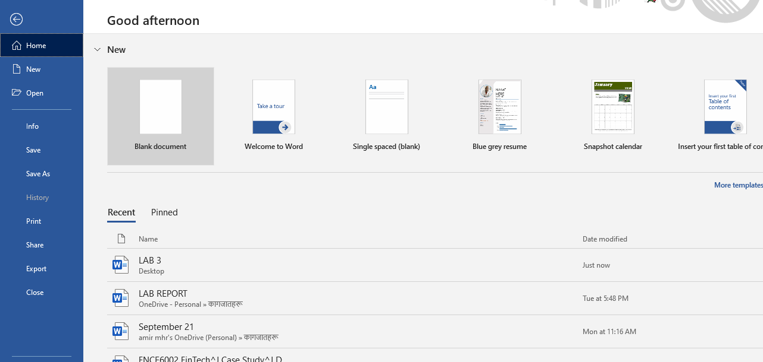

After selecting create a blank page, you are given a new interface where all your work is done.

**HOME TAB**

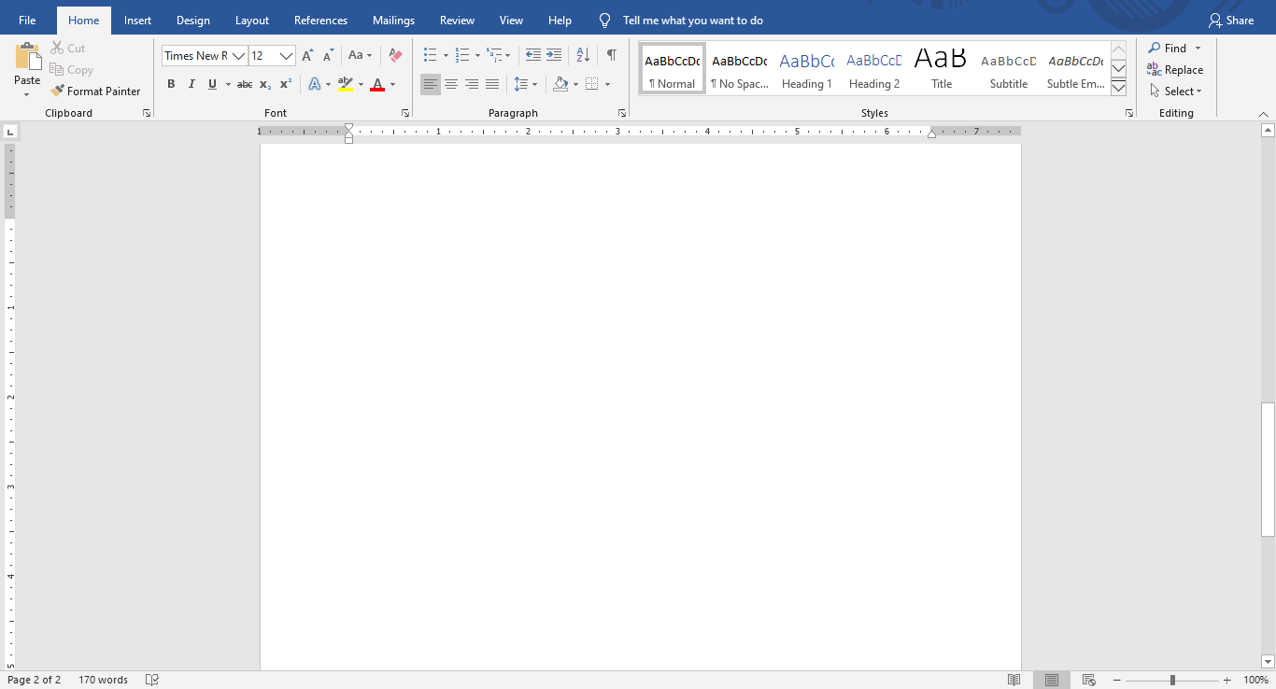

In the blank page, you can type anything. In this interface you can change the font, font size, color, make it bold, italic, etc.

**INSERT TAB**

Insert is the next tab. In this tab you can insert pictures, add a new page, insert a table, chart. It also enables the user to insert page number, header, footer, symbol.



**DESIGN TAB**

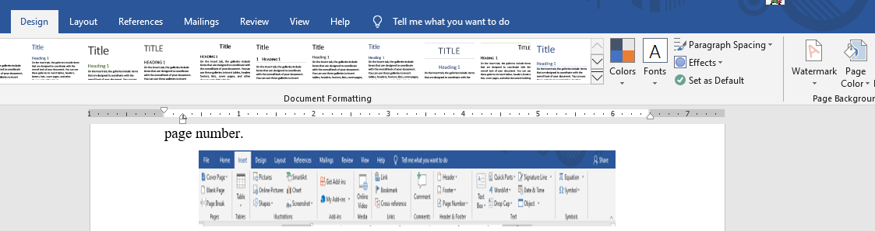

In design tab we also can add a watermark in our document file. Steps To insert a watermark:

* First go to design tab.
* In the top right corner, you can see watermark option, click on it and you can add a watermark in you document file.

Here, we also can also manage paragraph spacing, effects and many more.